Image and Video Processing – Lab1

* Name: Kunchanapalli Manohar
* Enrolment Number: E18CSE093

Input Image (for task 1) :

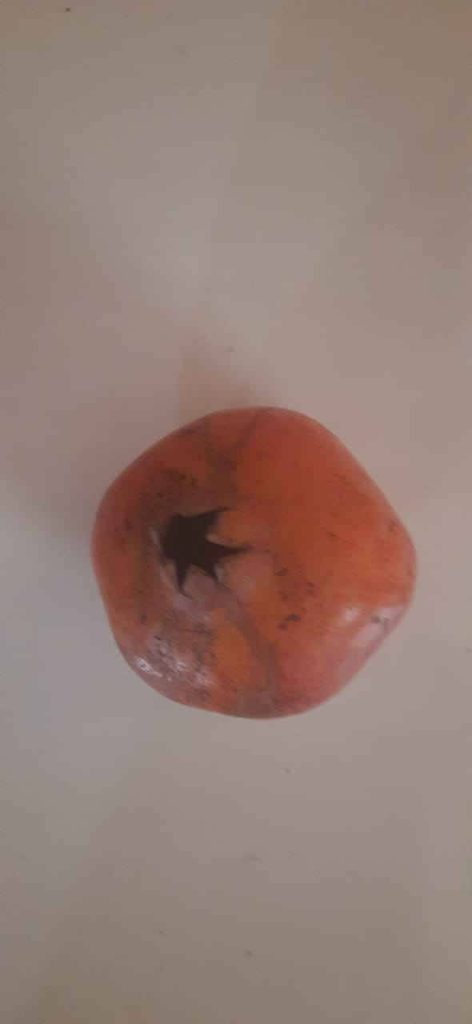

1. Using MatplotLib Library:

Reading the Image

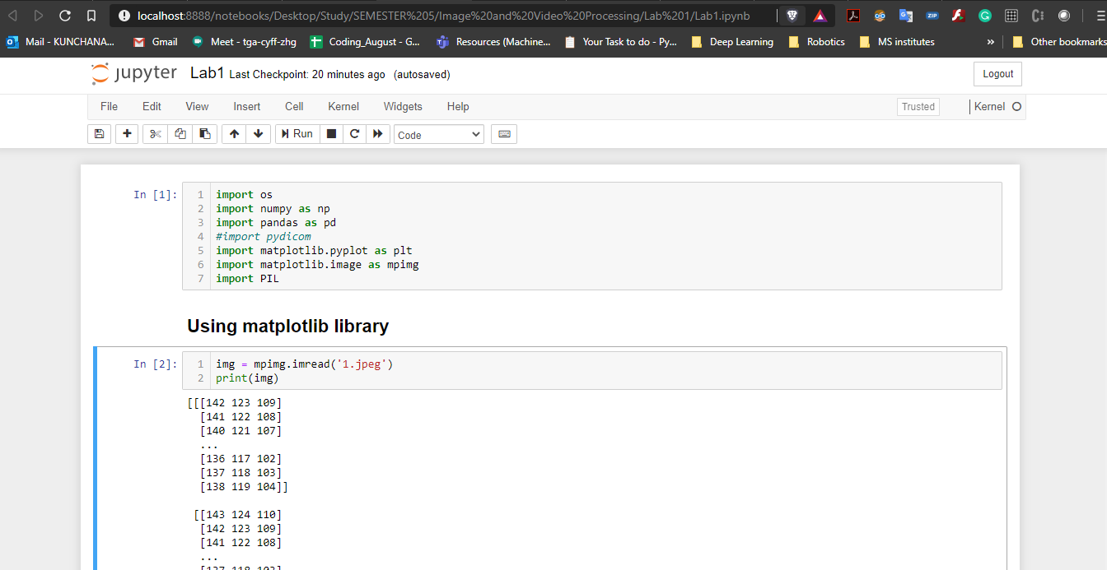

Finding the shape of the image; plotting image; saving image

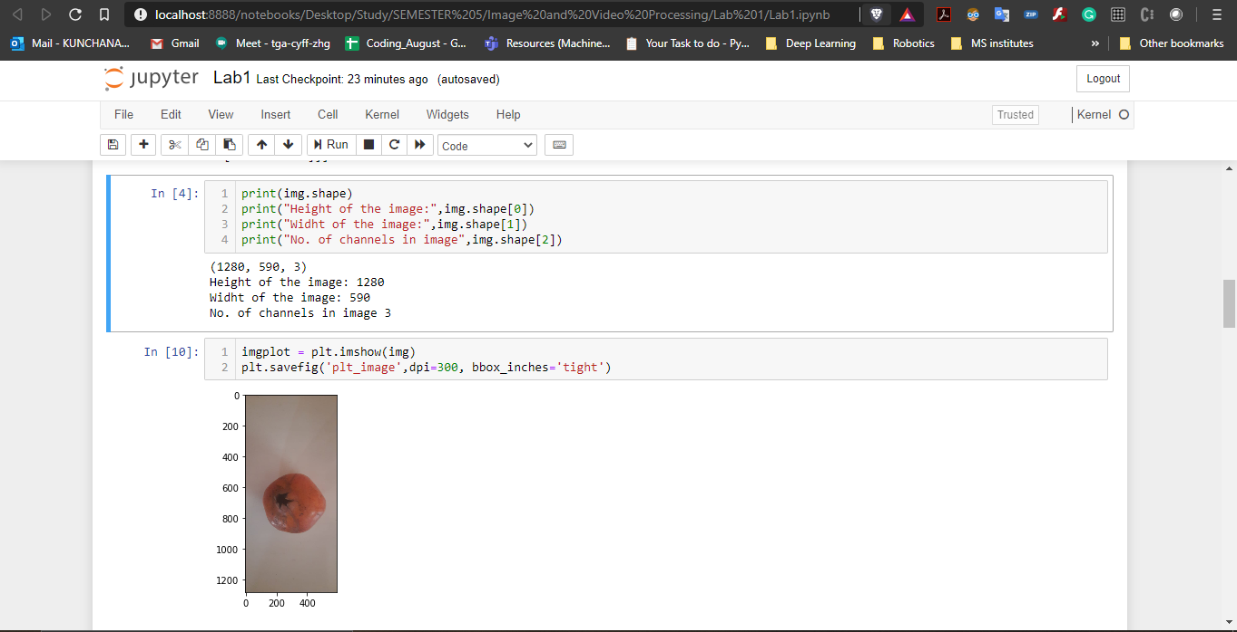

1. Using PIL library:

Reading image; shape of the image; plotting the image

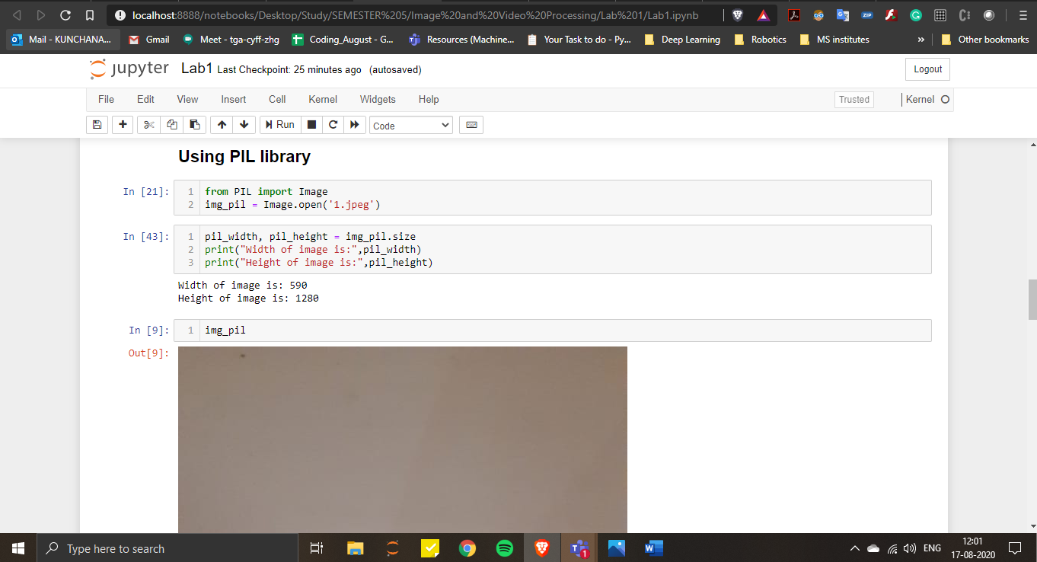

Output of the image

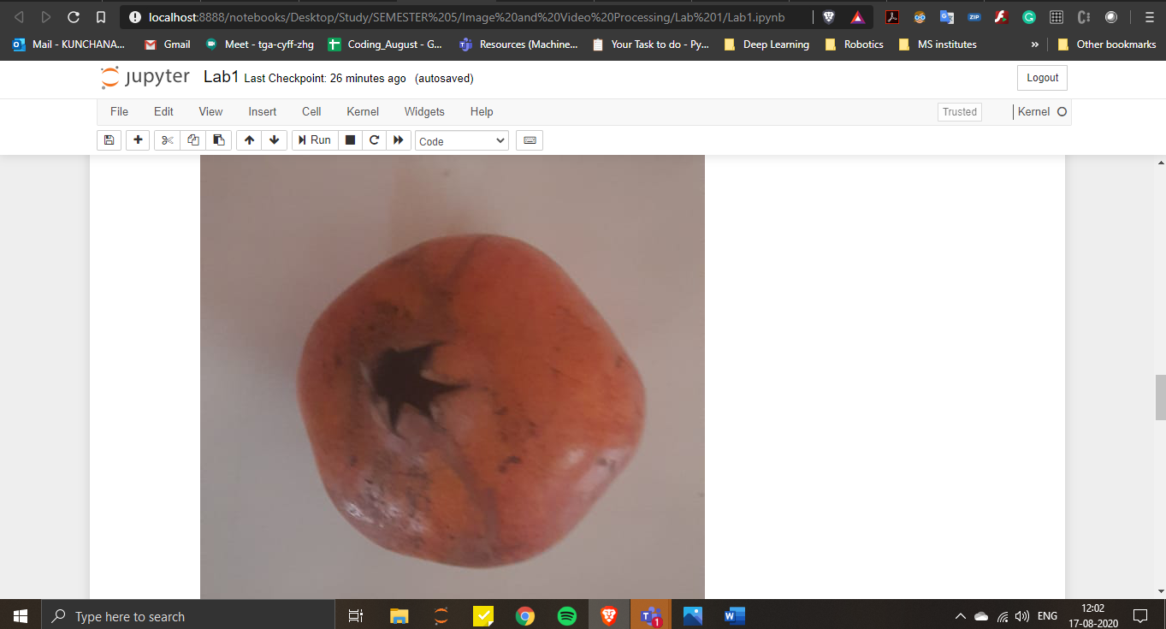

Saving the Image

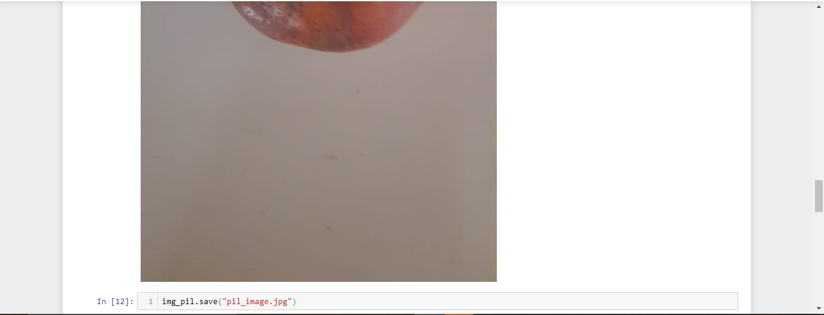

1. Using SKImage

Reading the image; plotting image;

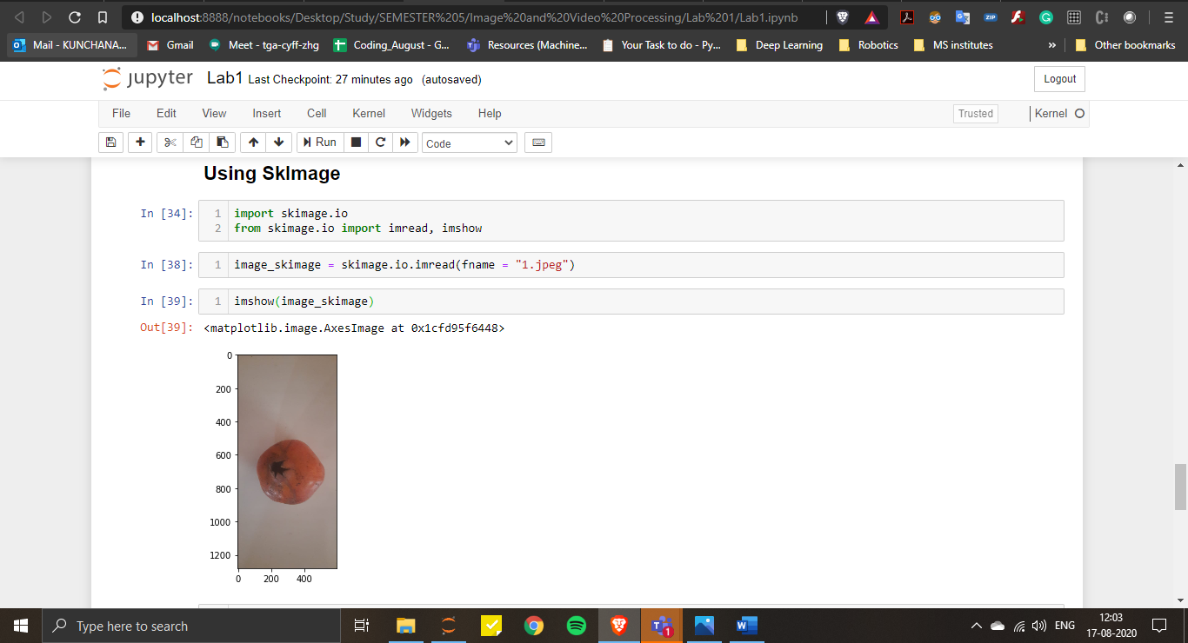

Shape of the image; saving the image

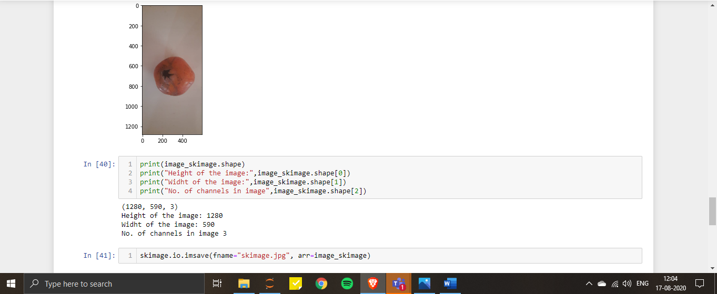

1. Reading a grayscale image in raw format from a file

Reading the raw file; reshaping the image

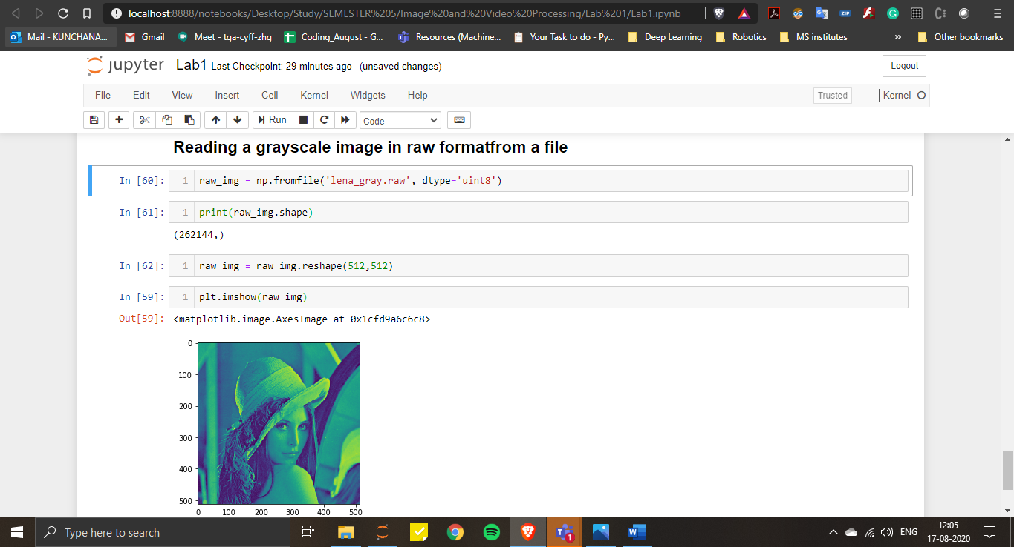

Saving the image into raw file

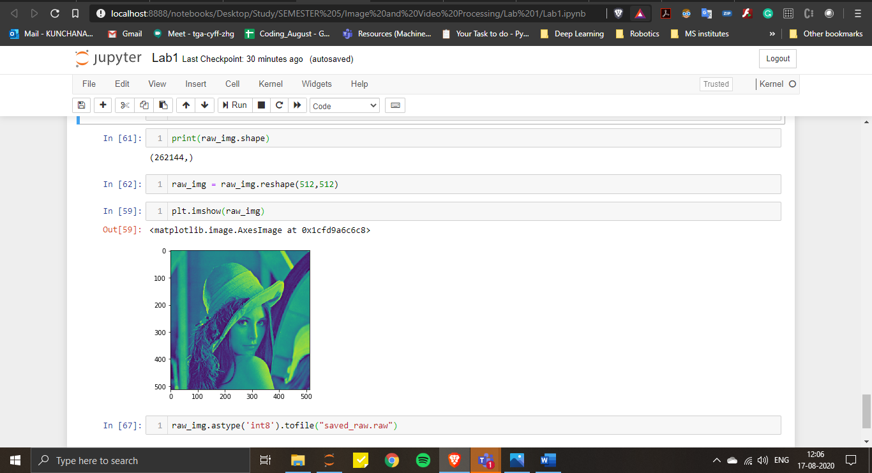

Viewing image in photopea

